Preparing the Camera Ready Paper for ICEST 2012 Proceeding of Papers
Ludwig Lubich¹ and Ivo Dochev²
¹Ludwig Lubich is with the Faculty of Telecommunications at Technical University of Sofia, 8 Kl. Ohridski Blvd, Sofia 1000, Bulgaria, E-mail: icest@tu-sofia.bg.
²Ivo Dochev is with the Faculty of Telecommunications at Technical University of Sofia, 8 Kl. Ohridski Blvd, Sofia 1000, Bulgaria.

Abstract – In this paper the instructions for preparing camera ready paper for the Conference ICEST 2012 are given. The recommended, but not limited text processor is Microsoft Word 97/2000/XP/2003. The global instructions for preparing paper with any text processor are given, too.

Keywords – Camera ready paper, Proceedings of papers, ICEST 2012.

- Introduction
In order to effect high quality of ICEST 2012 Proceeding of Papers the authors are requested to follow instructions given in this sample paper. Use this document as a template if you are using Microsoft Word. The deadline for receipt of camera ready papers is March 12, 2012. Maximal length of the regular papers is 4 pages, and for invited paper 10 pages. It is desired to occupy even number of pages (2 or 4 for regular and 8 or 10 for invited). Every paper should be uploaded to the conference web site http://icestconf.org both in Microsoft Word and in Adobe PDF format, i.e. two files are required for each paper.
- Instructions for the authors
A. Page Layout
Times New Roman 10 points font should be used for normal text. Paragraphs should be indented 3.5 mm.
Manuscript have to be prepared in two column separated by 5 mm. Please, equalize the length of the columns on the last page.
The paper format must be A4 (210×297 mm²). The margins are given in Table 1.
Table I
Page layout description
Top margin | 20 mm
Bottom margin | 34 mm
Left margin | 14 mm
Right margin | 14 mm
Column Spacing | 5 mm
B. Title, Author and Affiliation
Title must be written using 22 pt font, in two lines, centered. The spacing between title and authors line is 6 mm. Authors’ names (without affiliation) should be typed using 14 pt font. Authors’ affiliation (institution, address and e-mail) should be given in the bottom of the first column using 9 pt font. Please do not write telephone and fax number.
C. Abstract and Keywords
In the beginning of the paper abstract and keywords should be given. Abstract should be about 50 words. It is recommended to use up to five keywords. Please use 9 point bold font for abstract and keywords, and 9 point italic font for the words “Abstract” and “Keywords”.
D. Sectioning
Regular paper may be divided in a number of sections. Section titles (including references and acknowledgement) should be typed using 12 pt fonts in the SMALL CAPS option. For numbering use Roman number. In invited paper only sections can be split in subsection, which should be typed 10 pt Italic option. The space after section or subsection title is 4 mm. Spacing of 5 mm is used between the last section or subsection number and the next (sub) section title.
E. Equation
Equations should be centred and labelled. The example of equations is Eq. 1:
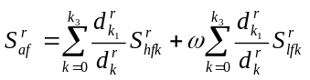 (1)
Larger equation must be split in a multiple lines, as shown in the example of Eq. 2:
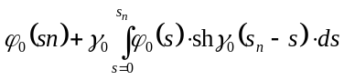
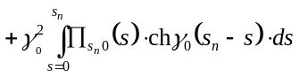
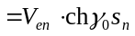 (2)

F. Figures
Figures should be one column wide. If it is impossible to place figure in one column, two column wide figures is allowed, but in this case figure must be located at the top of the page. Each figure must have a caption under the figure. For the figure captions 9 pt font should be used.

An example is given in Fig 1. All figures must be mentioned in text.
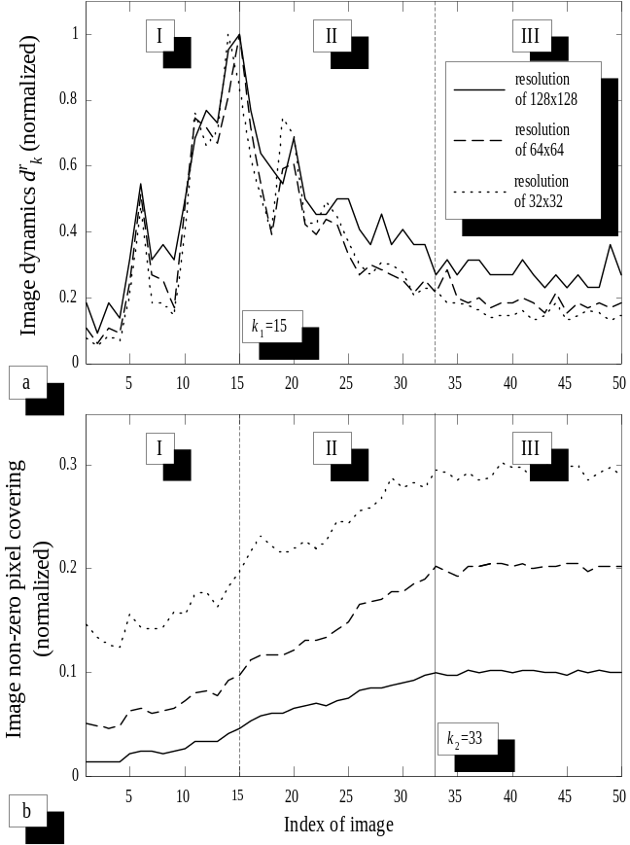
Fig. 1. Figure example
G. Tables
Tables also should be made as one column. In some rare cases it is allowed to use two column tables at the top of the page. Tables must have caption located above the table. Table caption should be written using 9 pt SMALL CAPS font. Example is Table I given above.
H. Referring
When you refer to an equation, a figure, a table, a section or a literature reference in the text of the manuscript please use the following expressions: Eq. (1), Eqs. (1) and (2), Fig. 1, Figs. 1 and 2, Table I, Tables I and II, Section 1, Sections 1.1 and 1.5, [1], [2].
I. References
The examples for the referencing a journal paper, a conference paper, and a book according to IEEE transactions are given in REFERENCES Sections [1-3]. For text in the references 9 pt font should be used.
- Additional Remarks
In order to be included in the final Program and Conference Proceedings your paper must reach the Technical Program Committee no latter than March 12, 2012. The camera-ready paper must be uploaded to the conference web site http://icestconf.org in both formats, listed below:
1. An original document written in one of the recommended text processors (Microsoft Word 97/2000/XP/2003, for example).
2. A camera-ready paper in Adobe PDF format.
- Conclusion
In this paper the instructions for preparing camera-ready paper for including in the Proceedings of Papers of the Conference ICEST 2012 are given.
Acknowledgement
For the acknowledgement use the unnumbered section layout.
References
- P. Watson, K. C. Gupta, “EM-ANN Models for Microstrip Vias and Interconnects”, IEEE Trans., Microwave Theory Tech., vol. 44, no. 12, pp. 2395-2503, 1996.
- B. Milovanovic, Z. Stankovic, S. Ivkovic and V. Stankovic, "Loaded Cylindrical Metallic Cavities Modeling using Neural Networks", TELSIKS'99, Conference Proceedings, pp.214-217, Nis, Yugoslavia, 1999.
- S. Haykin, Neural Networks, New York, IEEE Press, 1994.

